**LMC trials - methods**

This series of experiments aims to estimate the sex ratios produced by sexual *Lysiphlebus fabarum* females when they are ovipositing under different LMC conditions (high, 1 foundress; moderate, 5 foundresses; low, 10 foundresses). A secondary aim is to determine the sex ratios over the period of emergence to estimate the potential for sexual selection under different mating systems at different times.

**Set up:**

2/1/2023 - mated grandmothers set up: 40 sexual wasps put into flowerpot cage with aphids

6/1/2023 - approx 80 beans planted in small pots

16/1/2023 - block 1 LMC trials (1.1 N = 7; 1.2 N = 5).

* 1.1 10:00 half a leaf with ~ 200 aphid nymphs added to bag, wasps added immediately after through hole in top. Hole sealed with masking tape.
* 1.2 16:00 leaf with ~200 aphid nymphs added at 10:00, wasps added in the afternoon.

17/1/2023 - block 2 LMC trials (2.1 N = 13; 2.2 N = 9).

* 2.1 8:00 used plants with aphids added yesterday (16/1/2022 at 10:00)
* 2.2 16:30 leaf with ~200 aphids added to plant today by Arianna.

18/1/2023 - block 3 LMC trials (3.1 N = 12; 3.2 N = 13)

* 3.1 8:30 used plants with aphids added yesterday (17/1/2022) afternoon.
* 3.2 15:30 used plants with ~200 aphids added to plant today by Arianna.

Set up data can be found [here.](https://stir-my.sharepoint.com/:x:/r/personal/rb76_stir_ac_uk/Documents/Lysiphlebus/Experiments/LMC%20Jan%202023/LMC%20blocks%201-3%20data.xlsx?d=wd5f37d8ed2b445ef857242dea3fff5c0&csf=1&web=1&e=JFhl1b)

**Isolating mummies:**

25/1/2023-27/1/2023 mummies isolated from all plants. Removed mummies with a dissecting loop and placed in a small insect rearing dish or tub. Checked plants 1-34 for mummies twice.

On the first day (28/1) of emergence for block 1.1 and 1.2 (and day before emergence for block 2.1) plants were cut and removed from pots. They were placed into large deli cups with fine mesh tops. This allowed any parasitised aphids that were not yet mummies to continue to develop without the aphids continuing to breed rapidly on the live plant. On 29/1 the plants from block 2.1 (first day of emergence) and block 3.1 and 3.2 (day before emergence) were also cut and placed in deli cups.

**Data collected**

Wasps started to emerge on 28/1/23 (block 1), 29/1/23 (block 2) and 30/1/23 (block 3).

From 28/1/23 petri dishes and deli cups checked twice a day for emergence, once in the morning (10:00-12:00) and once in the afternoon (16:00-18:00). All emerged wasps in each dish/cup into an eppendorf, which was labelled with the ID number and date/time point. Eppendorfs containing wasps were placed in the freezer overnight and then dead wasps were sexed and counted under a dissecting microscope.

Collection times:

1 – 28/1/23 10:40-11:44

2- 28/1/23 16:07-18:00

3 – 29/1/23 10:30-12:00

4 – 29/1/23 16:00-17:25

5 – 30/1/23 10:00-11:30 (dishes); 11:30-12:00 & 13:45-14:30 (cups)

6 – 30/1/23 16:09-17:05 (dishes); 17:05-18:06 (cups)

7 – 31/1/23 09:54-11:08 (dishes); 11:20-12:20 (cups)

8 –31/1/23 16:00-16:50 (dishes); 16:50-17:30 (cups)

9 - 01/02/23 10:00-11:30 (dishes & cups)

- Unemerged mummies from 1.1 (1-7) counted.

10 – 01/02/23 16:00-17:30 (dishes and cups)

- Unemerged mummies from 1.2 (8-12) counted.

11 – 2/2/2023 10:00-10:30 (dishes); 10:30-12:06 (cups)

- Unemerged mummies from 2.1 (13-25) counted.

12 – 2/2/2023 16:00-16:30 (cups); 16:30-16:36 (dishes)

- Unemerged mummies from 2.2 (26-34) counted.

13 – 3/2/2023 10:30-10:34 (dishes); 10:35-11:02 (cups).

- Unemerged mummies from 3.1 (35-46) counted.

14 – 3/2/2023 16:10-16:12 (dishes); 16:12-16:30 (cups)

- Unemerged mummies from 3.2 (47-59) counted.

**End point**

Five days after the first day of emergence (block 1: 1-2-23 (1.1 am; 1.2 pm); block 2: 2-2-23 (2.1 am; 2.2 pm) block 3: 3-2-23; block 3.1 am; block 3.2 pm) was taken as the last time point for trials. After that date any mummies were removed from the dishes/cups and the number of unemerged wasps counted (based on the presence of an emergence hole in the mummy) and recorded.

Last update 3/3/2023 17:52

**Data analysis**

Calculated cumulative number of males and females per tube, calculated sex ratios at each time point (this was standardised for the time each tube was set up – days post parasitism for each block). Plotted sex ratios (proportion males) at each time point for each treatment (cumulative sex ratio, assuming no dispersal; emergence sex ratios, assuming males and females disperse; female dispersal sex ratios, assuming females disperse but males remain (number of males is cumulative). Also calculated overall sex ratio – total males emerged per tube/total emerged per tube.

i.e.

|  |  |  |  |  |  |  |  |  |  |
| --- | --- | --- | --- | --- | --- | --- | --- | --- | --- |
| Tube ID | Time point | Males | Females | Emergence Sex ratio | Cumulative males | Cumulative females | No dispersal sex ratio | Female dispersal sex ratio | Overall sex ratio |
| 1 | 1 | 3 | 1 | 0.75 | 3 | 1 | 0.75 | 0.75 |  |
| 1 | 2 | 2 | 2 | 0.5 | 5 | 3 | 0.625 | 0.71 |  |
| 1 | 3 | 4 | 4 | 0.5 | 9 | 7 | 0.5625 | 0.69 |  |
| 1 | 4 | 1 | 3 | 0.25 | 10 | 10 | 0.5 | 0.77 | 0.5 |

Ran some quick binomial GLMMs (Treatment*Time) and GLMs (just Treatment for overall sex ratio) and found no effects of treatment on sex ratio at all. Sex ratios (emergence, no dispersal, female dispersal, overall) were consistent across treatments. Here are some graphs:

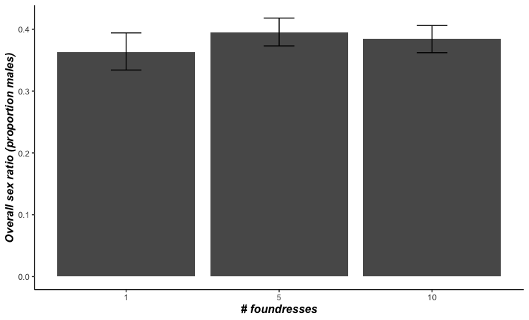

This is the overall sex ratio across treatments (sum males per tube/sum total per tube). There is no facultative sex allocation. Single foundress and multiple foundress sex ratios are the same.

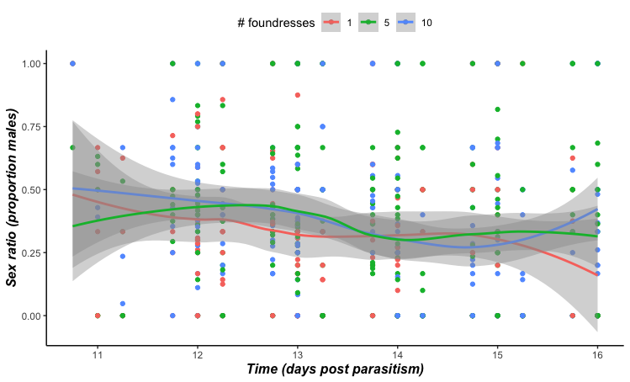

This is the sex ratio across all 3 treatments over time assuming males and females disperse after mating (I.e. counting only individuals that emerged at each time point, no previously emerged individuals)

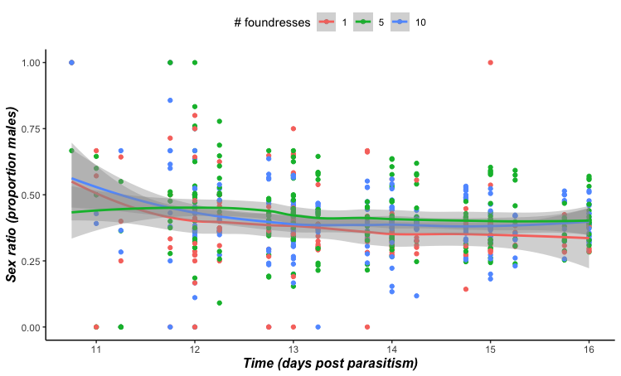

This is the sex ratio across all 3 treatments assuming no dispersal – the sex ratio is the cumulative total of males and females from all previous time points.

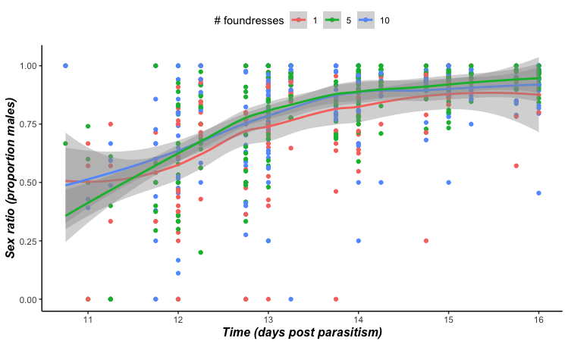

This is the sex ratio over time assuming females but not males disperse (cumulative sum of males, females as they emerge).

Only time had an effect on the sex ratio – for the cumulative sex ratio and the dispersal sex ratio it became more female biased over time. For the female dispersal sex ratio it became more male biased over time.

**Sex ratios for sexual selection trials**

Because of protandry sex ratios are slightly male biased at the start then they reach equality when female emergence exceeds male emergence, becoming slightly female biased for the remainder of the emergence period. Males were constantly emerging but sex ratios stayed fairly close to 0.4 (usually female biased).

The following treatment conditions reflect the sex ratios at different time points reasonably well:

|  |  |  |
| --- | --- | --- |
| Treatment | M | F |
| Male biased | 4 | 2 |
| Equal | 3 | 3 |
| Female biased | 2 | 4 |

See [cumul.means](https://stir-my.sharepoint.com/:x:/r/personal/rb76_stir_ac_uk/Documents/Lysiphlebus/Experiments/LMC%20Jan%202023/cumul_means.xlsx?d=w984b3d87bb5d41ad8a0a4381a678397c&csf=1&web=1&e=VLqwYB) spreadsheet for more details of sex raios per treatment at each time point. The absolute values of these could be changed depending on ease of observations.